Smoky Mountain Elementary School
Home of the Bears

Student & Parent Handbook

Smoky Mountain Elementary
135 S. Hwy 32
Cosby, TN 37722
Phone: (423) 487-2255
Fax (423) 487-5382

Principal
Jordan Williams

Assistant Principals
Tiffany Phillips

Bookkeeper
Brittany Hall

Secretary
Brittany Hall

Cafeteria Manager
Judith Shelton
Counseling/Guidance
Jill Breeden

School Board Member
John Johnson

Dear Parents and Students:

Welcome to the Smoky Mountain Elementary School Family! We thank you for trusting the staff of Smoky Mountain with the education of your children. We are looking forward to an outstanding year filled with terrific accomplishments.

We have created this Student/Parent Handbook and Code of Conduct for the convenience of students, parents, staff, and stakeholders of Smoky Mountain Elementary School. The handbook highlights important school policies and guidelines. Please read through this handbook with your child and discuss the importance of following school and district policies. We believe communication and understanding of these standards is critical in establishing well-being, safety, and satisfaction for all of our students, teachers, and parents. If you have questions or concerns related to school rules or district policies, you should contact the school principal, Jordon Williams, at (423)487-2255 or by email at williamsj3@cocke.k12.tn.us. The complete list of district policies can be found at https://cockecountyschools.org/.

Due to the expense involved in printing this handbook, it will be issued only once during the student’s enrollment at Smoky Mountain Elementary School. If the handbook is lost or destroyed, it can be accessed on the school website.
Together, I know we will make this school year one of growth and achievement for all children.

Sincerely,
Jordan Williams, Principal

Please make sure you ask about and sign up for the school’s Dojo code. Dojo is the main way we communicate with parents on a weekly basis.
Don’t miss out on important news!!

Table of Contents
Smoky Mountain School Stakeholder Expectations 5
Daily Schedule 7
Morning Procedures- 7
Afternoon Dismissal Procedures- 7
School Visitors - 8
Attendance and Truancy Policies - 8
Cafeteria Policies - 9
Kindergarten Admission- 10
Immunizations- 10
Transfers- 10
Medications- 10
Phone Calls- 11
Messages for Students / Transportation Plans- 11
Emergency Information Changes- 11
Child Custody Information- 11
Emergency Drills- 11
Lost and Found- 11
Weather-related Dismissal- 11
Edgemont School Transportation/Bus Policy 12
Dress Code- 13
Cell Phone / Personal Communication Device Policy- 14
Grading, Curriculum, and Promotion Policies- 16
Discipline/Student Conduct Policies- 17-23
Athletics 24

Smoky Mountain Elementary School Stakeholder Expectations

The role descriptions outlined on the following pages establish the areas of responsibility of each program and discipline. It must be remembered that quality education and good discipline call for the cooperation of all who are involved in the educational process.
==============================================================================

Responsibilities:
The principal has the responsibility to:
- Provide leadership at the school level for high quality education.
- Ensure an effective instructional program for all students under his or her jurisdiction.
- Support, guide, and teach the instructional staff in achieving a high quality education.
- Establish guidelines for student discipline.
- Attempt to solve school-related problems or conflicts of students, staff, parents, and community.
- Develop and maintain a plan to provide for the safety and welfare of both students and faculty.
- Develop and maintain communication and rapport with students.
- Understand and like students.
- Ensure that the rights of students are protected.
- Ensure that parents are notified of their child’s progress and any significant changes in their achievement and/or behavior.
- Establish and maintain a positive school climate, which provides frequent, realistic opportunities for students, staff, and parents to participate in the identification and resolution of school-related concerns.
- Adhere to the procedures set forth in system policies and this code.
The teacher has the responsibility to:
- Prepare and implement lesson plans and learning activities which provide an effective educational program for each student.
- Understand and like students.
- Maintain an orderly classroom.
- Deal with discipline problems reasonably, fairly, patiently, and without provocation.
- Work with parents to set up a conference time to discuss any student needs.
- Notify parents of their child’s progress and significant changes in their achievement and/or behavior.
- Participate in helping to identify and resolve school-related concerns.
- Adhere to the procedures set forth in the system policies and this code.
The parent or guardian has the responsibility to:
- Establish and maintain a positive attitude toward education in the home.
- Show an active interest in the student’s work and progress through regular communication with the school.
- Assist the student to be neat, clean, and well-groomed.
- Ensure the student’s regular daily attendance.
- Report and explain in writing any absence to the school.
- Become familiar with the student code of conduct, the school rules, and classroom rules.
- Cooperate with school personnel when disciplinary action is necessary concerning the student.
- Cooperate with school personnel in the maintenance of the student’s physical and emotional health.
- Understand the procedures set forth in system policies and encourage students to adhere to them.
- Respond to any communication from the teacher concerning student needs or problems.
- Work with the teacher to set up a conference time to discuss any student needs.
- Have a conference with the teacher if the student receives an “F” in any academic subject or an unsatisfactory conduct grade.
- Provide current telephone numbers and addresses at all times. (The school is not obligated to enroll or allow the attendance of a student whose parents have not provided a correct address.)
The student has the responsibility to:
- Attend all classes on time.
- Prepare for classes with assigned work and appropriate materials.
- Account for his/her work.
- Be neat, clean, and well-groomed.
- Conduct his or herself in a safe and responsible manner.
- Show respect for all individuals and property.
- Seek help from school personnel when having school/personal problems.
- Follow the rules and regulations established by the school and the classroom teacher.

Daily Schedule

Drop off and pick up procedures
Free Breakfast and lunch continues for our Smoky Mountain Elementary students this year!! This is such a blessing. If your child wishes to eat breakfast please have him/her at school by 8:00. Food will not be taken into the rooms this year.
As in years past, drop off is 7:15-8:15 at the main lobby doors. At 8:15 students are tardy and parents will need to walk the student to the door to sign in. Do not just send the student in as they must have parent/guardian signature.
At the morning drop off please remember to use the RIGHT LANE ONLY for drop off. Have all goodbyes finished and be prepared to have the student exit quickly on the right side of the vehicle. We ask for parents to stay inside the vehicle to assist with traffic flow. One slow vehicle can lead to dangerous traffic backing up on Hwy. 32.
If you feel you need a longer goodbye or your child is slower about getting out, then use parking lot in front of the porch. Then, you may walk your child to the main entrance. Do not sit in your vehicle and send him/her as this could be dangerous.
Afternoon pick up starts at 3:15. Please do not get in line prior to 2:45 so traffic is not blocked. Parents should stay in their vehicles and watch when to pull forward. Students will be dismissed to parents waiting in the traffic line. A personal suggestion is to wait until 3:25 to arrive at school and you will have a much easier experience. All students must be picked up by 3:45 unless they attend the after school program.

School Visitors -

Our top priority is to provide your child/children with a quality education in a safe learning environment. In order to maintain a safe environment, all parents and visitors ring the front bell and speak to the office staff.

Instructional time - The main concern of the faculty at Smoky Mountain Elementary School is to supply your child with a quality education. In order to do this, it is essential that instructional time have as few interruptions as possible. Each teacher appreciates the interest you have in your child’s education, and they are willing to meet with you about any of your concerns. However, parent/teacher conferences must be scheduled in advance so that instructional time is not lost. Teachers have the responsibility for classes and planning and cannot stop for unscheduled conferences. We request that you call the school to schedule an appointment if you need to meet with a teacher.

Open House (Parent/Teacher Conference Nights) - There will be two Open House sessions held each year. One session will be scheduled for each semester. The school will notify parents of the date and time of the session. These conferences allow the parents and teachers an opportunity to discuss student progress and achievement. Parents are urged to attend and be involved in their child’s education.

Attendance and Truancy Policies -

Attendance is a key factor in student achievement and therefore, students are expected to be present each day school is in session. Student achievement is negatively impacted anytime a student is absent, tardy, or leaves early. Parents are legally responsible to ensure his or her children are in school. Students should strive for perfect attendance. Please make every attempt to schedule doctor and dental appointments for afterschool hours. In the event of an absence, a note explaining the reason for absence should be provided to the student’s teacher.

Absences shall be classified as either authorized or unauthorized as determined by the principal or his/her designee. Authorized absences include: personal illness, illness of immediate family member, death in the family, extreme weather conditions, religious observances, signed parent notes of which no more than 5 may be used during the school year, circumstances which in the judgment of the principal create emergencies over which the student has no control, school sponsored activities, or subpoena to court.
Truancy is defined as an absence for an entire school day, a major portion of the school day or the major portion of any class, study hall, or activity during the school day for which the student is scheduled.

Students who are absent five (5) days without adequate excuse will be reported to the director of schools who will, in turn, provide written notice to the parents/guardians of the student’s absences. In addition, the principal/designee shall initiate meaningful communications with the student and parent/guardian in order to determine the underlying cause(s) of the unexcused absences. The principal/designee shall then develop an attendance plan and coordinate additional services designated to improve the student’s attendance.

Continual truancy problems are serious offenses and could result in citation to the Truancy Board or Juvenile Court.

Cafeteria Policies -
The National School Breakfast and Lunch Programs competitive food policy requires that:
- Students may bring a lunch from home, but they must eat their lunch in the cafeteria.
- Carbonated drinks are not allowed.
- No glass containers are permitted on school grounds.
- No competitive foods are allowed to come through the serving line. For example, if a student wants to bring food from an outside vendor, it could not be brought to the cafeteria in its original packaging or labeling.
Our system has opted to participate in the Community Eligibility Program (CEP), which means all of our students receive both breakfast and lunch at no charge.

Enrollment/Transfer Information

PreK Admission-
The following information is required for enrollment in Cocke County Schools:
- A birth certificate OR officially acceptable evidence of date of birth at time of registration.
- Physical Examination - by a doctor, health department, or health clinic.
- Tennessee Certificate of Immunization - TWIS Form - No other record of immunization will be accepted.
- Proof of Residency

Kindergarten Admission-
The following information is required for enrollment in Cocke County Schools:
- A birth certificate OR officially acceptable evidence of date of birth at time of registration.
- Physical Examination - by a doctor, health department, or health clinic.
- Tennessee Certificate of Immunization - TWIS Form - No other record of immunization will be accepted.
- Proof of Residency

Immunizations-
Students entering the seventh (7th) grade are required to have additional immunizations. An updated TWIS form documenting proof of the immunizations must be provided before the student can attend school.

"Exceptions to this may include students experiencing homelessness, students in foster care, immigrant students, migrant students, and English Language Learners. There will be no barriers to enrollment for these student groups."

Transfers-
In-state Transfers - School records will be requested from the previous school. It is the parent’s responsibility to provide information regarding immunizations.

Out-of-state Transfers - Tennessee State Law requires that no child shall be permitted to enroll in (or attend) any school without proof of immunization. It is the responsibility of the parents or guardians to have their children immunized. Proof of immunization is the Tennessee Certificate of Immunization (TWIS Form) which is obtained through a physician or the health department.
Medications-
No medication (Aspirin, Tylenol, etc.) can be given to your child by a staff member unless the medication is sent to school in the original container and accompanied by a note from the parent/guardian. If a child becomes too sick to stay at school, the school secretary, nurse, or principal will contact you to come and get your child.

Phone Calls-
If a student needs to use the telephone, they must obtain permission to come to office and make the call on an office phone. No cell phones will be allowed in calling of parents.

Messages for Students / Transportation Plans-
Only emergency messages will be delivered to students during the school day. Please plan ahead with your child/children to avoid unnecessary calls and messages.

If your child’s transportation plan is different from his or her normal routine (going home with someone else, riding/not riding the bus, etc.), please write a note to the teacher and make him/her aware of the change. No student will be allowed to walk home or ride a different bus without written permission from the parent or guardian.

Emergency Information Changes-
Any change of address, telephone number, or emergency contact should be reported to the school office immediately.

Child Custody Information-
Custody forms must be on file in the school office. It is the responsibility of the parent or legal guardian to provide current copies of custody papers to the school. Changes in custody should be reported to the school office immediately.

Emergency Drills-
There are three (3) types of emergency drills conducted during the school year: fire, tornado, and intruder drill. Teachers will teach and reinforce procedures for each event throughout the school year.

Lost and Found-
Articles found in and around the school should be turned into the school office. All items will be placed in the school’s lost and found which is located in the office. Identification is much easier when student names are written on backpacks, coats, bags, etc.

Weather-related Dismissal-
Parents need to have prior arrangements made for the care of his or her child or children in the event that school is dismissed early due to inclement weather conditions.

Smoky Mountain Elementary School Transportation/Bus Policy

General Information-
- Students will only be permitted to exit a bus at their designated destination unless written permission from his or her parents gives authority for the driver to do otherwise. Drivers will only deliver students to other destinations which are on their regular routes.
- Students must have a fixed location for catching the bus and arrive at that location on time.
- Students should stand well off the road and stand clear of the bus until it comes to a complete stop.
- Students who must cross the road to board a bus or reach their home from the bus must do so under the direction of the driver.

Rules and Policies-
- Students who ride buses to and from school are under school rules and regulations from the time they board the buses in the morning until they arrive at their appropriate destination in the afternoon. Students are required to follow all reasonable rules instituted by the driver. (See School Board Policy.)
- Drivers may assign students permanent seating on the bus if needed.
- Students will be responsible for any intentional damage caused to the bus.
- Consistent with school board policy, students who fail to comply with bus rules and regulations will be subject to disciplinary action including potential bus suspension or removal of bus privileges.

Dress Code-
Policy Number 6.310

Students shall dress and groom in a clean, neat and modest manner so as not to distract or interfere with the operation of the school.
More specific guidelines appropriate for each level of school (elementary or high school) may be developed. Principals, faculty members and students shall be involved in the development of each appropriate set of guidelines.
When a student is attired in a manner which is likely to cause disruption or interference with the operation of the school, the principal shall take appropriate action, which may include suspension.
ELEMENTARY (K-8) DRESS CODE
1. Shirts must not be cut below the normal armpit (boys and girls) and must not come below the top of the breast. All shirts must reach the top of pants, shorts, or skirts at all times (no skin showing).
2. Shorts may be worn by both males and females as long as the length is fingertip length.
3. The length of skirts and dresses must meet the same guidelines as shorts.
4. When leggings are worn, the shirt (or outermost garment) must adhere to the fingertip rule.
5. Clothes may not be worn with holes above the knees.
6. Appropriate undergarments are to be worn and must not be visible.
7. The waist of pants is not to be worn below the hips.
8. Clothing with inappropriate language or graphics is not permitted.
9. No clothing may have beer, whiskey, tobacco, drug labels or suggestive pictures or language written or printed on them.
10. Hats and/or caps are not to be worn during instructional time or at academic functions.
11. Students will not dress, groom or wear or use emblems, insignias, badges, or other symbols where the effect thereof is to distract unreasonably the attention of other students or employees, or otherwise cause disruption or interference with the operation of the school.
12. Any accessory that is studded, spiked, contains chains, or can tabs or in any way presents a potential danger or harm to self or others is prohibited.
13. Tattoos whether permanent or temporary will be covered if possible.
14. Visible body piercings are limited to the ear only. Eyebrow, nose, lip, tongue, etc… piercings are not permitted.
15. Anything in question will be at the discretion of the administrator.

Note: Compliance with dress code will be based on the outermost garment. For example, if a student chooses to wear tights/leggings, the student must have an outer garment that meets the standards of the dress code.

Dress Code/School Activity Exceptions: The school may develop special dress days for special occasions at the direction of the school principal which allow for an exception to the dress code (i.e. “Hat Day”, “Pajama Day”, etc.).

Special Situations: If a student cannot comply with the standardized dress code based on special conditions or religious beliefs, his or her parent or guardian may write a letter explaining the situation to the principal. If permission is granted, this letter will be kept in the student’s school record. Each case will be handled on an individual basis. Appropriate documentation will be required.

Dress Code Disciplinary Action-
- On the first offense, the student will receive a warning and be instructed not to wear the clothing item back to school and/or asked to change into more appropriate clothing.
- On the second offense, the parents or guardian will be notified to bring appropriate clothing to school.
- Any additional dress code offenses will result in office referral for disciplinary action.

Cell Phone / Personal Communication Device Policy-
Cell Phone Policy
Cell phones have become a way of life, a technological convenience that has impacted all of our lives in one way or another. However, in the school environment, cell phones have become a distraction, interruption, and a method of illegal exchange of information. The ringing of the cell phone during class or the text-messaging takes away from the valuable time needed for instruction and most importantly, student learning. We do recognize that cell phones can be a safety/security tool; however, they can be a detriment in the event of a building emergency and our protocol to manage such emergencies in a safe and effective manner. Parents are urged to utilize the school phone to relay any messages that may be urgent in nature to their child. We will do our best to relay any urgent information to your child.
No student will be allowed to possess or use a cell phone during the hours of 7:30am. to 3:45pm. Cell phones must be off and secured in each classroom. Each classroom will have a safe where students will deposit their cell phone every day. Only the teacher will have access to the safe. If a student is found to be in possession or use of a powered cell phone, the phone will be confiscated and sent to the office. These devices will not be used during the After School Program unless permission is given.
Our goal is to create a safe environment, conducive to learning, and free of all distractions that hinder the learning process.

Board Policy Number 6.312

Upon arrival on school grounds, students may possess a personal communication device with written permission from their parents. This permission will be kept on file in the school office. The personal communication device must be in the off mode and must be placed in a backpack, pocketbook or stored out of sight until the end of the school day. The principal or designee may grant a student permission to use the personal communication device at their discretion. Violation of this policy will result in the confiscation of the device. On the first offense, the student’s parent or guardian can retrieve the phone from the school. Additional violations would result in confiscation of the device for seven (7) calendar days for the second offense and thirty (30) calendar days for each offense thereafter. Should the device be confiscated within six (6) days before the end of the school year, it will be returned on the last school day. The device will be subject to search.
Should a student possess a personal communication device without parental permission, that device will be confiscated for thirty (30) calendar days on each infraction and the device will be subject to search. The device will be returned at the end of the school year if confiscated within twenty-nine (29) days before the end of the school year.
If the 7th or 29th day occurs during a school break (Christmas or Spring Break, etc.), the phone will be returned the first day school resumes.
Any and all personal communication or electronic devices are not required, nor does the school assume any responsibility should these items be lost, damaged, stolen or confiscated.
It is further the policy of the Cocke County Board of Education that the four paragraphs stated above are the minimum requirements regarding the use of cell phones on school grounds during instructional time. Individual schools are free to adopt more restrictive policies than written above so long as the same are submitted to and approved by the Cocke County Board of Education.

Grading, Curriculum, and Promotion Policies-

Report cards will be sent home at the end of each grading period. Parents should sign and return the report card to school. Written comments may be included when returning the report card.

Progress reports will be sent home every three/four and 1/2 weeks. They are to be signed by the parent/guardian and returned to the teacher within one week.

Honor roll is comprised of students who receive no less than a “B” in major content areas (Math, Reading/Language Arts, Science, and Social Studies).

Promotion/Retention- Policy Number 4.603
Students will normally progress annually in sequential order from grade to grade. The staff will place students at the grade level best suited to them academically, socially and emotionally. The determination of whether a pupil is promoted or retained in grade or which class he is assigned to is made by appropriate school officials, not others or parents. The law clearly authorizes the local board "through its officers and employees" to assign children not only to schools but also to "grades, classes, or courses of study within school." Retentions may be made when, in judgment of the teacher, such retentions are in the best interest of the student(s).

Grading scale

90-100 A
80-89 B
70-79 C
60-69 D
Below 60 - F

Discipline/Student Conduct Policies-

Students should always strive to obey all school rules. However, the principal and teachers are responsible for establishing and maintaining effective discipline within the school. All teachers have not only the right, but the responsibility and duty to reprimand or correct any student who is misbehaving. By state law, the principal and teachers stand “in loco parentis” (A Latin legal term meaning “in place of parent”) while the child is under their care and supervision.

School staff and parents must assume the responsibility for appropriate behavior in the school. We enlist the aid of parents and other staff members to maintain what we consider to be proper discipline and conduct. As a staff, we know our parents will be supportive of maintaining good discipline and conduct in our school.

Respect of Staff Members- Students should show respect for teachers and staff members at all times. Disrespect by students toward any teacher or staff member will not be tolerated. Disrespect to teachers and staff will result in disciplinary action.

Student-to-Student Conduct- Displays of public affection (kissing, “holding hands”, etc.) are not allowed on school grounds or at school-sponsored events.

Respect of Personal Property- Students are expected to show respect and be responsible for their actions toward other individuals and their property. Students should not take or damage the property of other students, school personnel, or the school system.

Students damaging school property will be responsible for restitution, replacement, or repair costs. They will also be subject to disciplinary action.

Student Valuables/Personal Property- Students are advised not to bring valuables/personal items (large amounts of money, electronics, cell phones, etc.) to school. The school will not be responsible for lost, damaged, or stolen personal property. Students are not allowed to sell or exchange items at school.

Lost Textbooks/Materials-
Lost books and materials assigned to the student must be paid for by the parents or guardian.

Textbooks/devices issued to students are the property of the Cocke County Board of Education. They should be used with care and returned in good condition. Students and parents are responsible to pay for books/devices which are lost, stolen, or damaged beyond repair.
The school will not issue any additional textbooks/materials and will withhold all grade cards, diplomas, certificates of progress, or transcriptions until restitution is made.

Drug-Free Schools, Alcohol, Tobacco-
Students will not consume, possess, use, sell, distribute or be under the influence of illegal drugs or alcoholic beverages in school buildings or on school grounds at any time, in school vehicles or buses, or at any school-sponsored activity, function or event whether on or off school grounds. This includes but is not limited to abuse of inhalants and prescription drugs.

Disciplinary sanctions will be imposed on students who violate standards of conduct required by this policy. Such sanctions will be consistent with local, state, and federal laws, up to and including suspension/expulsion as well as referral for prosecution.

Upon information that a student is suspected of violating this policy, the principal of the school shall be notified immediately. After inquiry and obtaining the facts, if the principal determines that a student has violated this policy, he shall notify the student’s parent or guardian and the appropriate law enforcement officials, suspend the student from school, and refer the matter to the Disciplinary Hearing Authority for further action; provided that no student shall be suspended without first having been provided due process.

Students shall not be allowed to use or be in possession of tobacco or tobacco products while on school property, on school buses, or while participating in school-sponsored activities. Students in violation of this policy will be subject to disciplinary action.

Weapons and Dangerous Instruments-
Students shall not possess, handle, transmit, use or attempt to use any dangerous weapon in school buildings or on school grounds at any time, or in school vehicles and/or buses or off the school grounds at a school-sponsored activity, function or event.

Dangerous weapons for the purposes of this policy shall include, but are not limited to a fi rearm or anything manifestly designed, made or adapted for the purpose of inflicting death or serious bodily injury or anything that in the manner of its use or intended use is capable of causing death or serious bodily injury.

Violators of this section shall be subject to suspension and/or expulsion from school.

In accordance with state law, any student who brings or possess a fi rearm on school property shall be expelled for a period of not less than one (1) calendar year. The director of schools shall have the authority to modify this expulsion requirement on a case-by-case basis.

Discrimination/Harassment-
Students shall be provided a learning environment free from sexual, racial, ethnic and religious discrimination/harassment. It shall be a violation of this policy for any employee or any student to discriminate against or harass a student through disparaging conduct or communication that is sexual, racial, ethnic or religious in nature. The following guidelines are set forth to protect students from discrimination/harassment.

Student discrimination/harassment will not be tolerated. Discrimination/harassment is defined as conduct, advances, gestures or words either written or spoken of a sexual, racial, ethnic or religious nature which:

1. Unreasonably interfere with the student's work or educational opportunities; or
2. Create an intimidating, hostile or offensive learning environment; or
3. Imply that submission to such conduct is made an explicit or implicit term of receiving grades or credit; or
4. Imply that submission to or rejection of such conduct will be used as a basis for determining the student's grades and/or participation in a student activity

Bullying/Intimidation-
Students shall be provided a safe learning environment. It shall be a violation of this policy for any student to bully, intimidate or create a hostile educational environment for another student. Harassment, bullying and intimidation occurs, if the act takes place on school grounds, at any school-sponsored activity, on school-provided equipment or transportation or at any official school bus stop, if the act either physically harms a student or damages his/her property, or knowingly places the student in reasonable fear of such, causes emotional distress to a student or students, or creates a hostile educational environment. If the act takes place off school property or outside of a school-sponsored activity, an act of harassment, bullying or intimidation occurs if the act is directed specifically at a student or students and has the effect of creating a hostile educational environment or otherwise creating a substantial disruption to the education environment or learning process. These acts may also take place through electronic means.

Alleged victims of the above-referenced offenses shall report these incidents immediately to a teacher, counselor or building administrator. Any allegations shall be fully investigated by a complaint manager (as set forth in Student Concerns, Complaints and Grievances 6.305).

Profane or Indecent Language-
Profane and indecent language will not be permitted on school grounds or buses.

Possession or Use of Explosives-
Any student who has in his or her possession any pyrotechnics (firecrackers, powders, explosives, ammunition or related materials) while on school grounds or bus shall be subject to suspension/expulsion from school.

Interrogation by School Official-
Students may be questioned by teachers or principals about any matter pertaining to the operation of a school and/or the enforcement of its rules. Questioning must be conducted discreetly and under circumstances which will avoid unnecessary embarrassment to the student being questioned. Any student answering falsely, evasively or refusing to answer a proper question may be subject to disciplinary action, including suspension.

If a student is suspected or accused of misconduct or infraction of the student code of conduct , the principal may interrogate the student, without the presence of parent(s)/guardian(s) or legal custodians and without giving the student constitutional warnings.

Searches-
Any principal, or his/her designee, having reasonable suspicion may search any student, place or thing on school property or in the actual or constructive possession of any student during any organized school activity off campus, including buses, vehicles of students or visitors (Notice shall be posted in the school parking lot that vehicles parked on school property by students or visitors are subject to search for drugs, drug paraphernalia or dangerous weapons), and containers or packages if he/she receives information which would cause a reasonable belief that the search will lead to the discovery of:

1. Evidence of any violation of the law;
2. Evidence of any violation of school rules or regulations or proper standards of student or faculty conduct;
3. Any object or substance which, because of its presence, presents an immediate danger of harm or illness to any person.

A student using a locker that is the property of the school system does not have the right of privacy in that locker or its contents. All lockers or other storage areas provided for student use on school premises remain the property of the school system and are provided for the use of students subject to inspection, access for maintenance and search. Notice shall be posted in each school that lockers and other storage areas are school property and are subject to search.

A student may be subject to physical search or a student’s pocket, purse or other container may be required to be emptied because of the results of a locker search, or because of information received from a teacher, staff member or other student if such action is reasonable to the principal. All of the following standards of reasonableness shall be met:

1. A particular student has violated policy;
2. The search could be expected to yield evidence of the violation of school policy or disclosure of a dangerous weapon or drug;
3. The search is in pursuit of legitimate interests of the school in maintaining order, discipline, safety, supervision and education of students;
4. The primary purpose of the search is not to collect evidence for a criminal prosecution; and
5. The search shall be reasonably related to the objectives of the search and not excessively intrusive in light of the age and sex of the student, as well as the nature of the infraction alleged to have been committed.

School Assemblies-
During assemblies and other special activities, courtesy should always be shown to guests. Entering and leaving the assembly should be orderly and quietly. Students violating these expectations will be subject to disciplinary action.

Field Trips-
All classes have the opportunity for educational field trips. Students whose behavior is uncooperative or consistently poor may be required to stay at school on field trip days.

Disciplinary Procedures-
Non-compliance with school rules and policies will result in corrective action being taken by administration. Disciplinary options may include but not limited to: removal from class for a period of time, penalty, loss of privileges, corporal punishment, suspension, expulsion, referral to Disciplinary Hearing Authority, or referral to juvenile court.

RTI₂-B
What is RTI2-B?
Response to Instruction and Intervention-Behavior (RTI2B) is a Multi-Tiered System of Supports (MTSS) that offers a powerful, evidence-based approach for meeting the behavioral and social needs of students in Tennessee schools.
RTI2-B is a promising framework for prevention and intervention within an integrated, three-tiered approach. Each tier of the framework involves careful reflection on the needs of students, the design of interventions matching those needs, and the collection of data to evaluate progress (individually for students and collectively as a school). All of these efforts require a shared school-wide commitment to teach and reinforce positive behavior. It also involves adopting an optimistic view that all students can learn appropriate behavior if sufficient and supportive opportunities to learn are provided. When using positive behavior supports in all three tiers (e.g., focusing on teaching students the behaviors we want to see, as opposed to punishing the behaviors we don’t want to see, and developing relationships between student and school staff), schools create a culture where all students and teachers are respected and included in their community. Furthermore, student and staff contributions to the school create a positive and proactive way to acknowledge, engage and respect all stakeholders.
The purpose of RTI2-B is to empower educators to equip all students with the opportunity to meet high expectations regarding behavior and the support to reach every student. Also, students, families, and educators can work together to develop and contribute to a shared school vision.
Within the multi-tiered framework of RTI2-B, each tier increases the intensity of intervention and supports so students can be best supported within their school.
Tier 1: Tier 1 focuses on the behavioral and social needs of all students across the school environment. Approximately 80% of students typically respond to this level of support. Tier 1 includes establishing school-wide expectations to support a sense of safety and inclusion among students and staff, teaching and modeling those expectations within different settings throughout the school, for responding to inappropriate behavior, and maintaining a school-wide system where all stakeholders’ opinions are valued.
Tier II: Tier II involves delivering more targeted interventions for approximately 10-15% of students who do not respond to Tier 1 supports. Tier II interventions are provided in addition to Tier 1 supports in place for all students in the school. Interventions at Tier II are typically systematic, evidence-based interventions that are delivered to groups of students at a time. For example, Tier II interventions typically include small-group social skills instruction, behavior contracts, self-monitoring plans, and check-in/check-out.
Tier III: Tier III includes individualized interventions for approximately 3-5% of students who do not respond to Tier I or Tier II interventions and supports. Tier III interventions involve the implementation of specialized, one-on-one systems for students. Examples of Tier III supports include individualized counseling and function-based interventions.

Smoky Mountain Student Athletics Program-

The word “athlete” includes the following: football players, basketball players, volleyball players, cheerleaders, water attendants, etc.

Students participating in the athletics program must observe the minimum guidelines:
- Provide written permission from parent/guardian.
- Pass a physical examination.
- Have health insurance.
- Complete the concussion training.
- Maintain appropriate grades in each subject area.
- Maintain good attendance.
- Obey the school rules.
- Meet any additional requirements assigned by the coach of that sport.

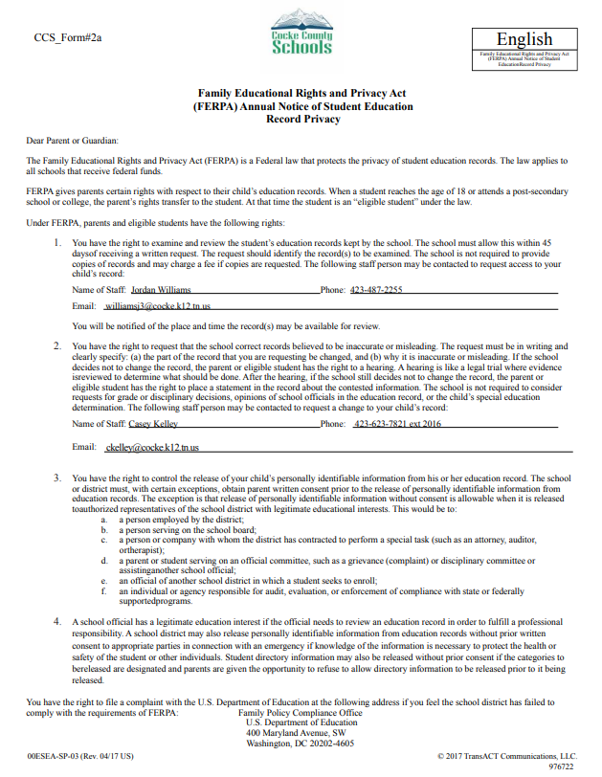

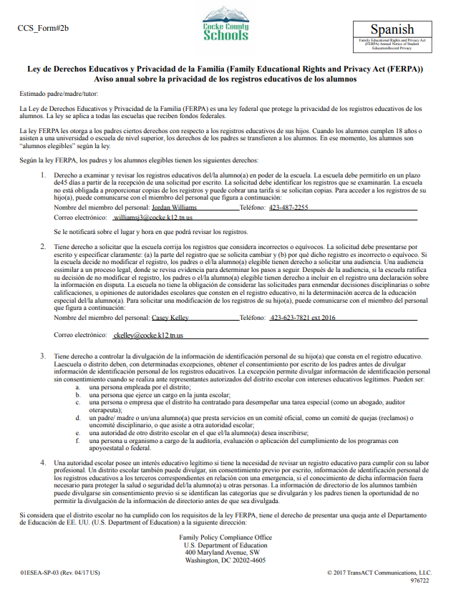

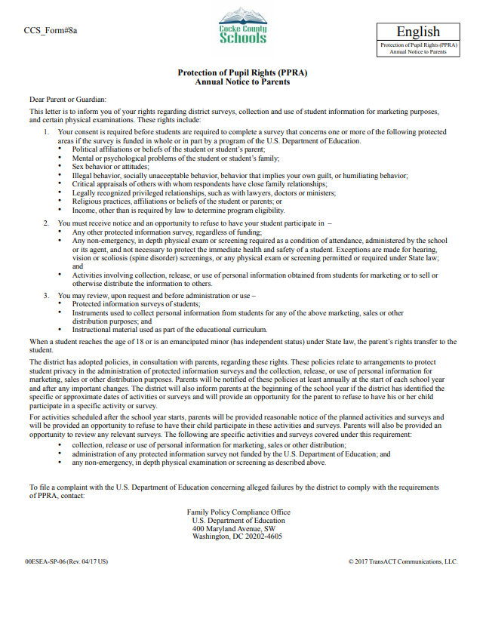

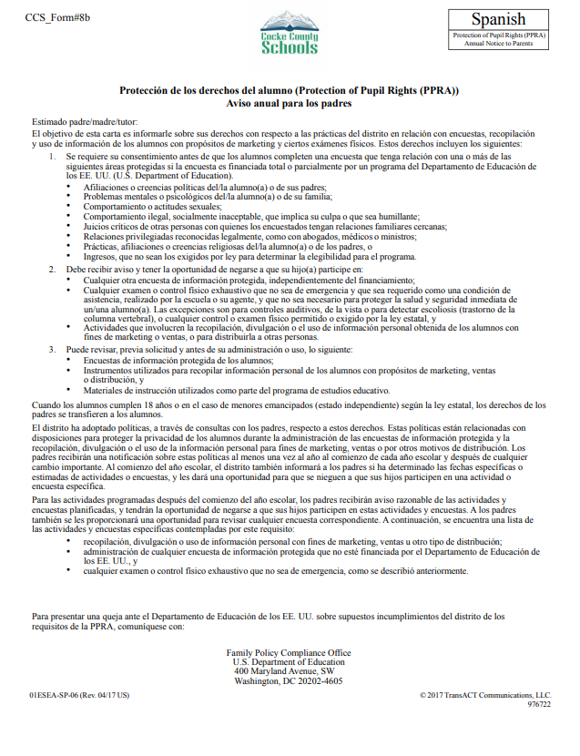

Receipt of Student Handbook

Please write the student name and sign as the parent or guardian to acknowledge that you have received this handbook and that you have read the contents of this handbook.

This will be kept on file as reference that you have received and read this handbook.

Student Name: _________________________________________

Parent/Guardian Signature: _______________________________

Date: _____________________________________

