**6th Grade English Language Arts**

**Smoky Mountain Elementary School**

**2025-2026 Syllabus**

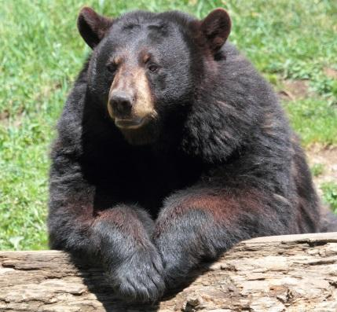

Welcome to 6th Grade!

6th grade ELA is a combination of the literacy skills: writing, thinking, speaking, reading, listening, and comprehending. This year we will once again strive to improve our writing, vocabulary, spelling, reading, punctuation, and grammar. Writing is a necessary skill that is used throughout life. We must continue to improve our word choice, fluency, sentence structure, paragraph development, and essays. ELA is the backbone of all our other subject areas. Reading and writing are the key to success!

Part 1: Course Information

Teacher Information

Teacher: Bobbie J. Stinson

School Telephone: 423-487-2255

E-Mail: [stinsonb@cocke.k12.tn.us](mailto:stinsonb@cocke.k12.tn.us)

Class Communication/Access: Aspen, ClassDojo, Appointments, Class Weekly Newsletter, Open House (twice a year), and Parent Involvement Meeting (twice a year)

Textbook and Required Materials

Amplify ELA – 2021 Amplify Education

Tennessee ELA State Standards – 6th Grade

Visit the link below to view the Tennessee State Learning Standards required for 6th grade ELA. These will be taught throughout the academic school year.

<https://www.tn.gov/education/instruction/academic-standards/english-language-arts-standards.html>

Grading Scale

Letter Grade Percentages Performance

A 90-100% Excellent Work

B 80-89% Above Average Work

C 70-79% Average Work

D 60-69% Below Average Work

F 0-59% Failing



Part 2: ELA Course Overview

*Each Monday a class newsletter will be sent home informing parents/guardians of upcoming events and assignments as well as the current course of study.

*We will be using AMPLIFY, the currently adopted ELA Program, a highly engaging and exciting ELA curriculum.

*We will be doing AR this school year as well. Students will be checking out library books weekly and taking AR quizzes on them. They will be required to meet their Reading goal every nine weeks as students will be expected meet goals and percentages.

*We will be using Mastery Connect in ELA for assessment.

*We will be taking the CASE Benchmark test three times this year for assessment.

*The TCAP test will be given for a final assessment at the end of the school year.

*Grades will be based on the following assignment types: classwork, exams, projects, quizzes, reading comprehension, tests, and writing assignments. Students’ grades will be weighted equally. Students’ grades will be posted to the ASPEN Grade Book.

*Make-Up Work should be completed as soon as possible. Please check with the teacher about missed work.

Part 3: 6th Grade ELA

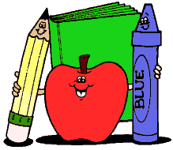

Course Calendar

| Unit 1: Narrative Reading & Argumentative (Opinion) Writing  Dahl & Narrative  Anchor Text: Boy: Tales of Childhood by Roald Dahl  Objectives:  *Students will understand the impression of a moment.  *Students will observe how an author creates a character.  *Students will use the writing process and techniques to produce an opinion about who causes more trouble in the book: the boys or the adults? Cite evidence.  Major Assignments: Personal Narrative Essay, Reading Project, Argumentative Writing |
| --- |

| Unit 2: Scientific and Technical Texts and Informational Writing  Mysteries and Investigations  Anchor Text: The Secret of the Yellow Death: A True Story of Medical Sleuthing by Suzanne Jurmain  Objectives:  *Students will read like an investigator of scientific and investigative sleuthing.  *Students will seek the truth about yellow fever.  *Students will write an informational essay about people that problem solve.  Cite evidence.  Major Assignments: Informational Essay, Reading Project, Informational Writing |
| --- |

*Extra Informational Writing instruction will be taught after Unit 2.

Course Calendar Continued

| Unit 3: Informational Essay and Argumentative Writing  The Chocolate Collection  Anchor Texts: Various informational articles concerning chocolate  Objectives:  *Students will read facts and stories about chocolate through the ages.  *Students will synthesize information from several sources to develop an argument.  *Students will complete scavenger hunts, debate, internet research, and a media project.  *Students will write an argumentative essay about whether chocolate should be included in school lunches. Cite evidence.  Major Assignments: Informational Essay, Scavenger Hunt, Debate, Media Project, and Argumentative Writing |
| --- |

*Extra Argumentative Writing instruction will be taught after Unit 3.

| Unit 4: Greek Mythology and Argumentative Writing  The Greeks  Anchor Text: Heroes, Gods, and Monsters of the Greek Myths by Bernard Evslin  Objectives:  *Students will explore three stories from Greek mythology: Prometheus, Odysseus, and Arachne.  *Students will consider the state of a single person concerning the role people play in the world and the various communities that they live.  *Students will write an essay arguing whether characters from two of these myths are destroyed by their pride. Cite evidence.  Major Assignments: Mythology Reading, Quest, Reading Project, Argumentative Writing |
| --- |

Course Calendar Continued

| Unit 5: Aztec Mythology and Narrative Writing  The Summer of the Mariposas  Anchor Text: Summer of the Mariposas by Guadalupe Garcia McCall  Objectives:  *Students will read a novel about the journey of the Garza sisters.  *Students will learn how characters change and develop.  *Students will write a narrative essay about one of the heroes being successful.  Major Assignments: Aztec Mythology, Narrative Writing |
| --- |

*Extra Narrative Writing Instruction will be taught after Unit 5.

| Unit 6: TCAP Review  Poetry in America  Anchor Texts: Various Narrative, Opinion, and Informational Texts  Objectives:  *Students will analyze texts using learning standards taught throughout the year to practice and reinforce testing skills.  *Students will complete the poetry unit as well.  Major Assignments: TCAP Test |
| --- |

Course Calendar Continued

| Unit 7: Informational Essay and Narrative Writing  The Titanic Collection  Anchor Texts: A Letter from Mary Lines  Objectives:  *Students will research to understand what happened with the Titanic.  *Students will learn the difference between primary, secondary, and tertiary sources. Also, if sources are reliable and ethical pieces of information to use.  *Students will write a narrative writing essay from the point of view of a passenger.  Major Assignments: Informational Essay, Research, Narrative Writing |
| --- |

Part 4: Attendance, Class Participation, and Projects

Attendance is one of the important factors to a successful academic school year. Attendance is crucial to sixth grade success. Participation is another important factor to a successful academic school year. Please make every effort to be here and participate. We take notes daily in class and your work all year long is so important.

Projects:

1st Nine Weeks - Speech

2nd Nine Weeks – The Chocolate Collection

3rd Nine Weeks – The Greeks

4th Nine Weeks – The Titanic Collection