**6th Grade Science Syllabus**

**2025-2026**

**Welcome to 6th Grade Science! This course is designed to provide students with a solid foundation in scientific principles and inquiry. We will explore the world around us through hands-on activities, experiments, class discussions, and project-based learning. Students will develop critical thinking skills, learn to work collaboratively, and gain a deeper appreciation for the natural and physical sciences.**

SIXTH GRADE: OVERVIEW The academic standards for sixth grade establish the content knowledge and skills for Tennessee students necessary to prepare them for the rigorous levels of higher education and future job markets. The course provides students with a wealth of scientific practical experiences. The academic standards for science in sixth grade are based on research and the National Research Council’s Framework for K-12 Science Education. The academic standards herein establish the core content and practices of science and engineering, as well as what Tennessee students need to know by the end of sixth grade. Disciplinary core ideas for sixth grade include:

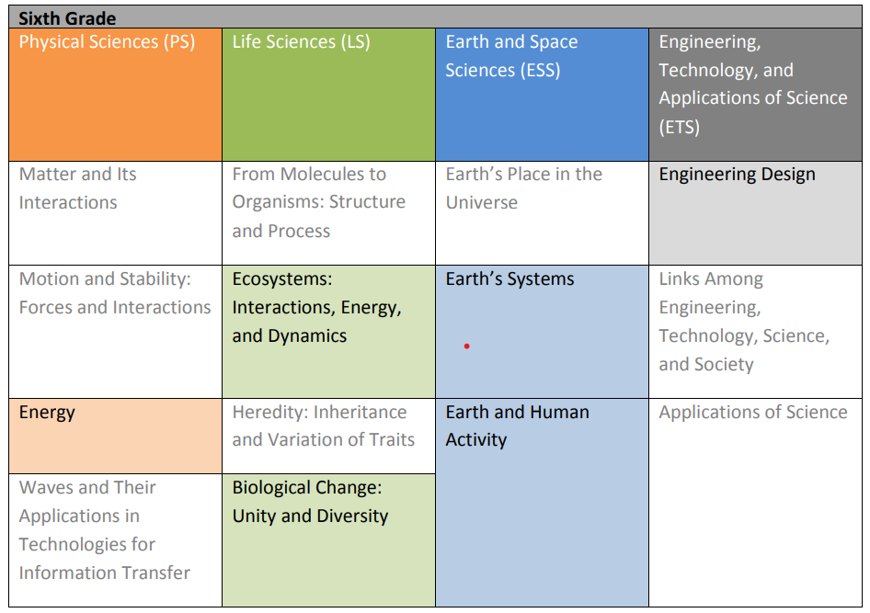

**UNITS OF STUDY**

| Topic 1: Energy | STANDARDS  6.PS3.1, 6.PS3.2, 6.ETS1.2 |
| --- | --- |
| Topic 2: Ecosystems, Populations, and Energy | STANDARDS  6.LS2.1, 6.LS2.2, 6.LS2.3 |

| Topic 3: Ecosystems, Health, and Biodiversity | STANDARDS  6.LS2.4, 6.LS2.5, 6.LS4.1, 6.ETS1.1 |
| --- | --- |
| Topic 4: Earth’s Hydrosphere and Atmosphere | STANDARDS  6.ESS2.1, 6.ESS2.2, 6.ESS2.4 |

| Topic 5: Earth’s Climates | STANDARDS  6.ESS2.3, 6.ESS2.6, 6.ESS2.7 |
| --- | --- |
| Topic 6: Earth and Human Activity | STANDARDS  6.ESS2.5, 6.ESS2.6, 6.ESS3.1, 6.ESS3.2, 6.ESS3.3 |

**Grading:**

Students will receive grades through assessment programs Mastery Connect, Edulastics, class work, and projects. These assessments will all use the 100 point grading scale, as I do not weigh grades.

**Missed Work:**

If a student is absent, students will receive any notes and or information given during class. Also assessments of any kind will have an extended due date. I will communicate with the student what needs to be made up during their absence. I always allow students to make up work when absent.

**Projects:**

The only project that will need to be completed at home will be a Science Fair Project. Students will get to choose a project based on their interests and must be approved by the teacher. The dates of the project will be communicated with the families weeks in advance to ensure ample time for completion.

### Science Fair Project Categories

**Option 1. Demonstration Project**

* Goal: To showcase a scientific principle or concept through a demonstration.
* Qualifications:
  + Must clearly explain the scientific concept behind the demonstration.
  + Should include a visual or interactive component.
  + Cannot be a simple model; it must demonstrate a process or reaction.
  + Examples: Volcano eruption with baking soda and vinegar, magnetic field visualization, water density layers.

**Option 2. Scientific Method Project**

* Goal: To conduct an experiment following the scientific method to answer a question.
* Qualifications:
  + Must include a testable question, hypothesis, experiment, data collection, and conclusion.
  + Should follow proper scientific controls and variables.
  + Must provide a display board with results and findings.
  + Examples: Testing which type of water helps plants grow best, studying the effects of different temperatures on yeast activity.

**Option 3. Engineering Project**

* Goal: To design, build, and test a new invention, structure, or solution to a problem.
* Qualifications:
  + Must identify a problem and propose an engineered solution.
  + Should include design plans, testing, and modifications based on results.
  + Must document the engineering process from concept to completion.
  + Examples: Building a bridge from popsicle sticks to test weight capacity, designing a water filtration system.

### Grading Rubrics

#### Demonstration Project (100 Points)

| **Criteria** | **Points** |
| --- | --- |
| Explanation of Concept | 30 |
| Creativity & Presentation | 20 |
| Clarity & Organization | 20 |
| Visual/Interactive Component | 20 |
| Overall Effort | 10 |

#### Scientific Method Project (100 Points)

| **Criteria** | **Points** |
| --- | --- |
| Hypothesis & Question | 20 |
| Experiment Design & Execution | 25 |
| Data Collection & Analysis | 25 |
| Presentation & Clarity | 20 |
| Overall Effort | 10 |

#### 

#### Engineering Project (100 Points)

| **Criteria** | **Points** |
| --- | --- |
| Problem Identification & Solution | 20 |
| Design Process & Creativity | 25 |
| Testing & Modifications | 25 |
| Presentation & Clarity | 20 |
| Overall Effort | 10 |

**Grading Scale:**

**100-90 A**

**89-80 B**

**79-70 C**

**69-60 D**

**59 and below F**

**Required Materials:**

* Earbuds or Earphones
* 1 Notebook
* 1 pencil pouch with colored pencils or crayons
* 1 Trifold Board or visual aid for a Science Fair Project

#### Classroom Expectations

1. **Be Respectful:** Treat your classmates, teacher, and classroom equipment with respect.
2. **Be Safe:** Follow all school safety rules. Science is a hands-on subject, and safety is our number one priority.
3. **Be On Task:** Complete all assignments, notes, and projects on time and take ownership of your learning.

*Every action, word spoken, or interaction will fall under one of these rules.

**ASSESSMENTS WINDOWS**

**SCIENCE CASE ASSESSMENTS**

**1st Cumulative Benchmark: Sept. 29th – Oct. 3rd**

**2nd Cumulative Benchmark: Dec. 10th – 18th**

**Final Comprehensive Benchmark: March 11th – 20th**

**TCAP ASSESSMENTS**

**April 13th - May 1st**

I am excited to have a fun and educational year with all of you! Please feel free to contact me with any questions or concerns through DOJO.

Thank you!

Mrs. Phillips

5th & 6th Math and Science Teacher