# **6th Grade Social Studies**

**Smoky Mountain Elementary School**

**2025-2026 Syllabus**

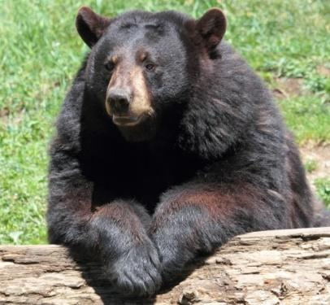

# **Part 1: Course Information**

**Instructor Information**

**Instructor: Bobbie J. Stinson**

**School Telephone: 423-487-2255**

**E-Mail:** [**stinsonb@cocke.k12.tn.us**](mailto:stinsonb@cocke.k12.tn.us)

**Class Communication/Access: ASPEN, ClassDojo, Appointments, Class Weekly Newsletter, Open House (twice a year), and Parent Involvement Meeting (twice a year)**

**Textbook and Required Materials**

**World History and Geography – Ancient Civilizations Textbook**

**2020 McGraw-Hill Education**

**Tennessee State Standards – 6th Grade**

**Social Studies:** [**https://www.tn.gov/education/instruction/academic-standards.html**](https://www.tn.gov/education/instruction/academic-standards.html)

**Grading Scale**

| **Letter Grade**  **A**  **B**  **C**  **D**  **F** | **Percentage**  **90-100%**  **80-89%**  **70-79%**  **60-69%**  **0-59%** | **Performance**  **Excellent Work**  **Above Average Work**  **Average Work**  **Below Average Work**  **Failing** |
| --- | --- | --- |

**Part 2: Student Learning Outcomes**

6th Grade Social Studies Course Overview

· **Students will learn proper time designations and analyze the development and characteristics of civilizations, including the effects of the Agricultural Revolution.**

· **Students will analyze the geographic, political, economic, and cultural structures of the civilization of ancient Mesopotamia.**

· **Students will analyze the geographic, political, economic, and cultural structures of ancient Egypt.**

· **Students will analyze the geographic, political, economic, and cultural structures of ancient Israel.**

· **Students will analyze the geographic, political, economic, and cultural structures of ancient India.**

· **Students will analyze the geographic, political, economic, and cultural structures of ancient China.**

· **Students will analyze the geographic, political, economic, and cultural structures of ancient Greece.**

· **Students will analyze the geographic, political, economic, and cultural structures of ancient Rome.**

Students will meet the objectives listed above through a combination of the following activities in this course which are weighted equally:

* -Daily Class Participation and Note-taking/Discussion
* -Quizzes and Chapter Tests
* –Posters/Tri-folds Illustrating Standards Based Topics of Study (Projects)
* -Slide Show Presentations Regarding Curriculum Based Topics (Projects)
* -Essays based upon reading texts and textual evidence. (Projects)
* –Binder

**Part 3: Topic Outline/Schedule**

1st 9 weeks

| Topic | Standards |
| --- | --- |
| Neolithic/Paleolithic Civilizations | 6.01-6.02 |
| Agricultural Revolution | 6.03-6.04 |
| Ancient Mesopotamia | 6.05-6.12 |
| Ancient Egypt | 6.13-6.19 |

2nd 9 weeks

| Topic | Standards |
| --- | --- |
| Ancient Israel | 6.20-6.24 |
| Ancient India | 6.25-6.30 |
| Ancient China | 6.31-6.38 |

3rd 9 weeks

| Topic | Standards |
| --- | --- |
| Ancient Greece | 6.39-6.50 |
| Begin Ancient Rome | 6.51-6.57 |

4th 9 weeks

| Topic | Standards |
| --- | --- |
| Ancient Rome | 6.51, 6.57-6.58 |
| Fall of the Roman Empire and The Byzantine Empire | 6.61-6.62 |
| Essential Aspects of Christianity | 6.59-6.61 |

Part 4: Attendance, Class Participation, and Projects

Attendance is one of the important factors to a successful academic school year. Attendance is crucial to sixth grade success. Participation is another important factor to a successful academic school year. Please make every effort to be here and participate. We take notes daily.

Projects:

1st Nine Weeks – Egyptian Pharaohs

2nd Nine Weeks – Chinese Dynasties

3rd Nine Weeks – Greek Gods/Goddesses

4th Nine Weeks – 12 Apostles